**Name**:Mohamed Khaled Ali Mohamed

**B.N/698**

**Date**:6-6-2021

**Topic**:Programming Languages

**Application Brief**:I chose this topic because I am interested in it. There are many programming languages trending that are well-suited for different development categories such as mobile applications, web application, distributed system, [game development](https://www.wikihow.com/Make-Computer-Games), etc.

**GitHub-Link:**

**<https://github.com/mohamedkaled123/html-project-repository>**

**GitHubPage(PublishedWebsite):**

**<https://mohamedkaled123.github.io/html-project-repository/figure.html>**

**Screenshots**:

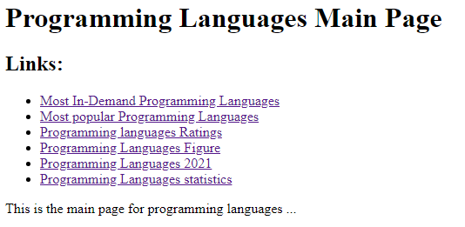

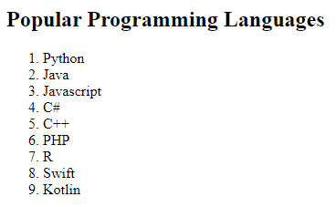

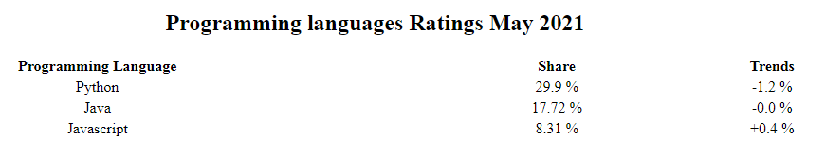

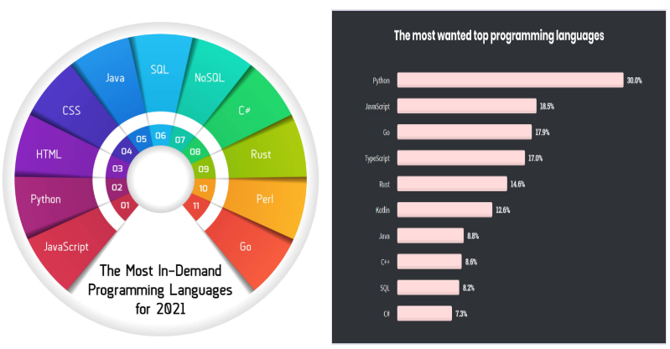

**Source Code**:

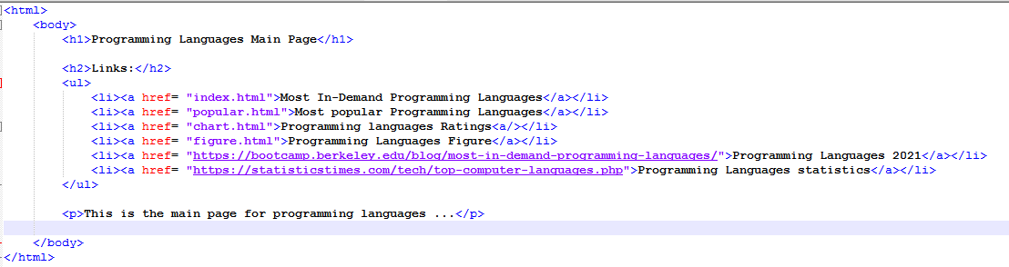

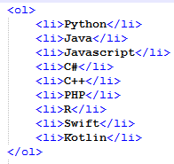

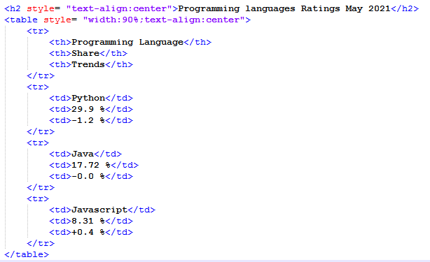

4